2024 NICHOLAS COUNTY SCHOOLS
WIDE AREA NETWORK
REQUEST FOR PROPOSALS

- Awards will be made in the best interest of the Nicholas County Schools.

- Nicholas County Schools may accept or reject in part, or in whole, any bid.

- All quotations are governed by the West Virginia Code and Policy 8200.

- All services performed or goods delivered under Nicholas County Schools Purchase Orders/Contracts are to be continued for the term of the Purchase Order/Contracts, contingent upon funds being appropriated by the Legislature or otherwise being made available. In the event funds are not appropriated or otherwise available for these services or goods, this Purchase Order/Contract becomes void and of no effect after June 30.

- Payment may only be made after the delivery and acceptance of goods or services.

- Interest may be paid for late payment in accordance with the West Virginia Code.

- Nicholas County Schools is exempt from Federal and State taxes and will not pay or reimburse such taxes.

- Any additional taxes or fees must be disclosed and included in quoted prices.

- The Purchasing Director may cancel any Purchase Order/Contract upon 30 days written notice to the seller.

- The laws of the State of West Virginia and Policy 8200 shall govern all rights and duties under the Contract, including without limitation the validity of this Purchase Order/Contract.

- Any reference to automatic renewal is hereby deleted. The Contract may be renewed for two additional years only upon mutual written agreement of the parties.

INSTRUCTIONS TO BIDDERS

- Bids are to be received in the form of sealed bids at the Nicholas County Schools Board Office located at 400 Old Main Drive, Drive Summersville, WV 26651, with 3 (three) paper copies and 1 (one) electronic copy (CD or flash drive). Address all proposals to the attention of “Technology” with “E-Rate Sealed Bid” noted on the exterior of the envelope. Bids are due by noon on the day of bid opening.

- Bids will be publicly opened at the Nicholas County Board of Education, 400 Old Main Drive, Drive Summersville, WV 26651, at 2:00 p.m. on February 13, 2024.

- Any and all bids may be rejected if there is a sound documented reason.

- An approved purchase order is required before the merchandise or service is ordered.

- SPECIFICATIONS: Items offered must be in compliance with the specifications. Any deviation from the specifications must be clearly indicated by the bidder. Alternates offered by the bidder as “equal to” the specifications must be clearly defined. A bidder offering an alternate should attach complete specifications and literature to the bid. The Purchasing Director may waive minor deviations to specifications.

- A quotation response must be provided that includes and identifies any installation costs, other non-recurring costs, monthly recurring charges, taxes and fees by location for each speed requested. The provided Form W-9, Purchasing Affidavit, No Debt Affidavit, Agreement Addendum (WV-96), and the Vendor Information Sheet must also be completed and enclosed.

- Unit prices shall prevail in case of discrepancy.

- The vendor must clearly instruct on the bid document if the vendor wishes to have the payment sent to a different "remit to" address other than the address on this document.

CERTIFICATION OF NON-CONFLICT OF INTEREST

According to W. Va. Code §61-10-15, It shall be unlawful for any member of a county commission, overseer of the poor, district school officer, secretary of a board of education, supervisor or superintendent, principal or teacher of public schools, or any member of any other county or district board, or for any county or district office to be or become pecuniarily interested, directly or indirectly, in the proceeds of any contract or service, or in furnishing any supplies in the contract for, or the awarding or letting of, which as such member, officer, secretary, supervisor, superintendent, principal, or teacher, he/she may have any voice, influence or control.

2024 NICHOLAS COUNTY SCHOOLS WAN RFP

SCOPE OF WORK

The Nicholas County Board of Education is soliciting a Request for Proposal for the installation of Wide Area Network service commencing with E-rate funding year 2024 as indicated below. The existing WAN contract expires on June 30, 2024. The Board reserves the right to modify the project as deems necessary. This RFP and the winning bidder’s response shall become an integral part of the resultant contract. The project must include termination of each circuit at a switch or media converter owned and maintained by the vendor at each termination location MDF (Nicholas County School District buildings).

The proposal shall include initial installation (non-recurring charges) and monthly recurring service charges that shall be priced separately for each service location.

Any questions related to the technical aspects of this document should be directed to nicholas.2024@naa.com.

● The vendor must quote a turn-key solution that will be installed, tested, fully operational, and accepted by Nicholas County Schools within ninety (90) days after issue of purchase order. This should occur to start services by July 1, 2024. Billing should only begin once all circuits have successfully completed testing and turn-up.

● In case of service interruption, the vendor must include in their quoted service price a four-hour “back in service” response time from the time of notification by an authorized Nicholas County Schools representative during regular business hours.

● The vendor must include an explanation of the capabilities of their centralized network testing, trouble correction system, and procedures utilized during the service outage. In addition, the vendor must allow the Nicholas County Schools representative to monitor the utilization of bandwidth and traffic flow at all switch ports at the NOC through a web interface. Please provide screen shots of the interface.

● All circuits in this RFP response will transport full quoted bandwidth for Nicholas County Schools use only.

● Preference may be given to the provider who can offer county-wide services via a turn-key WAN proposal rather than via subcontracting services or lease/resale. Please specify in detail the extent if any of services that are intended to be provided by a subcontractor or through lease/resale.

● Nicholas County School District reserves the right to award to multiple vendors, selecting portions of the vendors’ solutions best suitable for County’s needs. Nicholas County School District reserves the right to accept or reject any or all bids and waive minor informalities.

● Vendors must include a copy of their service agreement with their proposal.

● Proposed pricing shall be provided for a one-, three-, and five-year term commencing July 1, 2024, with an option for two 1-year signed, voluntary, renewals. Vendor’s contract must include a fiscal year funding-out clause. Vendor must agree to sign contract agreement addendum. (See Attachment A)

● Nicholas County School District will select the most cost effective, most qualified, and most responsive and responsible bidders when making the award. The evaluation of each proposal will have the heaviest weight assigned to price (complete installation costs, all other one-time costs, and monthly recurring costs for a period of the contract duration). Evaluation may also be based on, but not limited to, prior experience of Nicholas County School District with the respondent, technical capability and quality of work performed in other networks, and qualification of personnel. Additional evaluation criteria may include the ability of the vendor to deliver a complete array of optional data transfer rates, the ability to provide a turn-key solution, and the ability of the district to monitor bandwidth usage and traffic flow through a web portal. The District reserves the right to use additional criteria as needed.

● The winning vendor will be required to have or obtain a SPIN number before the start of service and submit a Service Provider Invoice Form directly to USAC pursuant to E-rate procedures established by the federal government. The winning vendor will be required to comply with all applicable E-rate rules and regulations.

- The vendor must sign a Purchasing Policies and Procedures for local Education Agencies Agreement Addendum which will be sent to the vendor upon selection. This document notifies vendors of State laws and procedures. See Attachment A.

● The vendor shall provide a physical and logical Network Drawing of proposed network in Visio format and PDF format.

CIRCUIT SPECIFICATIONS

● One 1, 2, 3, 4, 5, 7, or 10 Gb/s connection from either the NOC at 400 Old Main Drive, Summersville WV, or vendors Hub, to the Southern POP, 1900 Kanawha Blvd E, Building 6 in Charleston, WV 25305. Please provide separate pricing for all options.

● If the vendor provides a hub in their network, each circuit shall also have an appearance at the Nicholas County Board of Education (NOC) location at a quoted bandwidth.

● The vendor may place their hub at the Nicholas County Board of Education, or their own NOC, utilizing their own core switch and then each circuit will be provided to the Nicholas County Board of Education at its specified speed.

● Minimum 1 Gb/s, 2 Gb/s, 3 Gb/s, 5 Gb/s, 7 Gb/s, or 10 Gb/s connection from all schools and NIFs listed below to the Nicholas County Board of Education or a hub. Please provide separate pricing for each option at each location.

● Nicholas County Schools reserves the right to change any circuit to any speed specified in this RFP and in the vendor’s response any time during the life of the contract with a 30 day notice to the vendor. All quoted transfer rates will be available for the life of the contract.

● If a facility of the Board should close, Nicholas County Board of Education reserves the right to cancel or relocate a circuit without termination charges or penalties during the course of the contract.

Please provide pricing for EACH option at EACH location on the following list of Nicholas County School District locations requiring service.

Entity Name | Address |  | SPEED
BIRCH RIVER ELEMENTARY SCHOOL | 379 Birch River Road | Birch River | 1G to 5G
BOARD OFFICE (Nicholas Co NOC) | 400 Old Main Dr | Summersville | 1G to 5G
CHERRY RIVER ELEMENTARY SCHOOL | 190 Riverside Dr | Richwood | 1G to 5G
GAULEY RIVER ELEMENTARY | 100 School Street | Craigsville | 1G to 5G
GLADE CREEK ELEMENTARY SCHOOL | 7950 Webster Road | Summersville | 1G to 5G
MOUNT LOOKOUT ELEMENTARY SCH | 1945 Mt. Lookout Road | Mount Lookout | 1G to 5G
MOUNT NEBO ELEMENTARY SCHOOL | Po Box 160 | Mount Nebo | 1G to 5G
NICHOLAS CO SENIOR HIGH SCHOOL | 30 Grizzly Road | Summersville | 1G to 5G
PANTHER CREEK ELEMENTARY SCH | 10068 Canvas Nettie Road | Nettie | 1G to 5G
RICHWOOD MIDDLE SCHOOL | 16414 Webster Road | Craigsville | 1G to 5G
SUMMERSVILLE ELEMENTARY SCHOOL | 108 Mckees Creek Road | Summersville | 1G to 5G
ZELA ELEMENTARY SCHOOL | 165 Country Rd | Summersville | 1G to 5G
TO WVNET | 1900 Kanawha Blvd E, Building 6 | Charleston | 5G to 10G

NICHOLAS COUNTY SCHOOLS
VENDOR INFORMATION SHEET FOR SEALED BID SUBMITTAL
WIDE AREA NETWORK RFP
BID OPENING FEBRUARY 13, 2024 AT 2:00 P.M.

VENDOR NAME: ___________________________________

VENDOR ADDRESS: ______________________________________

______________________________________

REMITTANCE ADDRESS: ___________________________________

___________________________________

CONTACT NAME: _________________________________

CONTACT PHONE NUMBER: _________________________

CONTACT E-MAIL ADDRESS: _______________________________

Please mark or initial to affirm that the following required information is enclosed in response to the Wide Area Network Request for Proposal for Nicholas County Schools:

____ Detailed Quotation Response with monthly recurring and non-recurring charges
by location for each speed requested.

____ Completed W-9 Form

____ Completed No Debt Affidavit

____ Completed Agreement Addendum (Form WV-96)

I agree to comply with the terms and stipulations included in the Wide Area Network Request for Proposal for Nicholas County Schools. This company is eligible to provide services through the e-rate program.

AUTHORIZED COMPANY REPRESENTATIVE SIGNATURE: ______________________________

PRINTED NAME OF AUTHORIZED COMPANY REPRESENTATIVE: __________________________
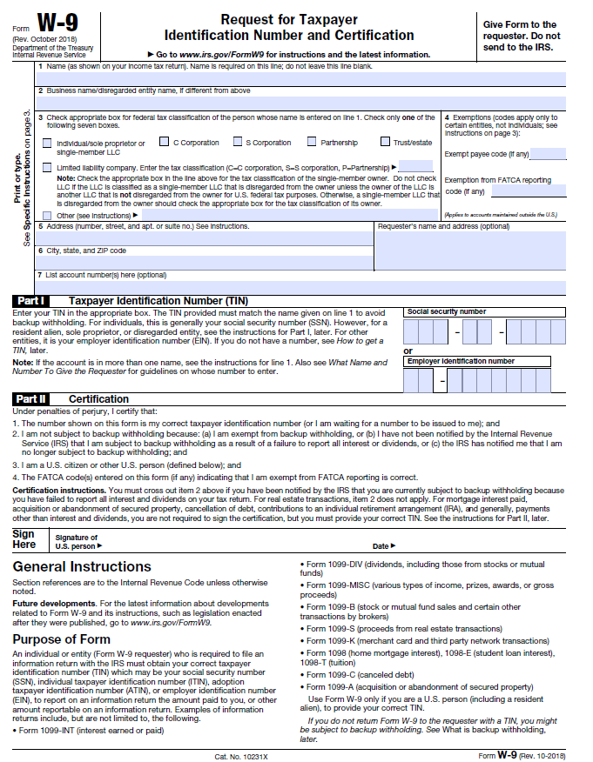
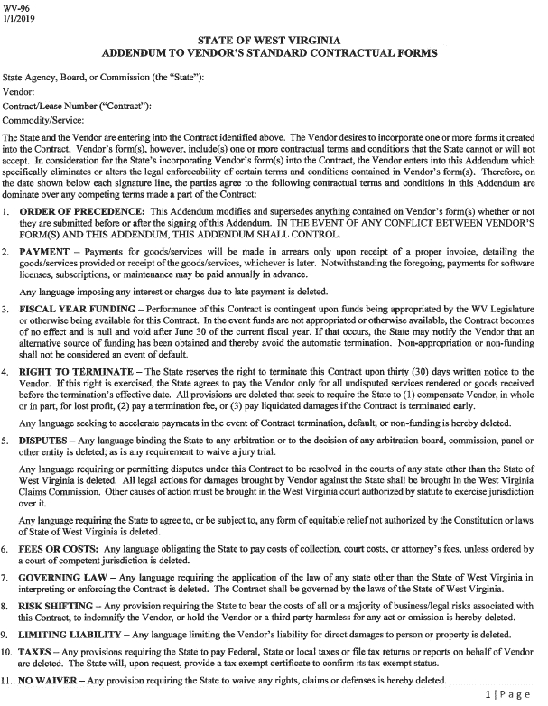
ATTACHMENT A
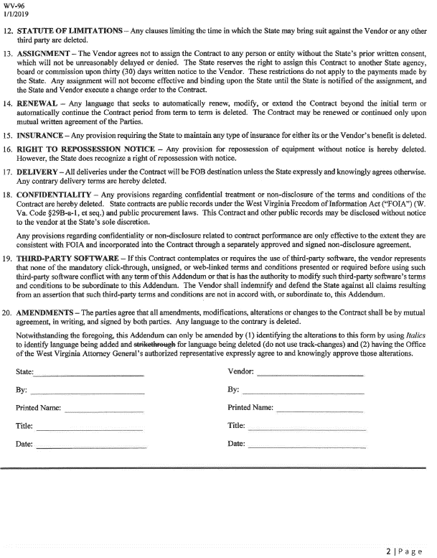

No Debt Affidavit

Instructions

The No Debt Affidavit is administered in accordance with the West Virginia Code, §5A-3-10A.

According to the statute, no contract or renewal of any contract may be awarded under this article to any vendor or prospective vendor when the vendor or prospective vendor or a related party to the vendor or prospective vendor is a debtor as defined in this section and the debt owed is an amount greater than $1,000 in the aggregate.

AFFIDAVIT

West Virginia Code §5A-3-10a states:

No contract or renewal of any contract may be awarded under this article to any vendor or prospective vendor when the vendor or prospective vendor or a related party to the vendor or prospective vendor is a debtor as defined in this section and the debt owed is an amount greater than five thousand dollars in the aggregate.

Definitions:

"Debt" means any assessment, penalty, fine, tax or other amount of money owed to the state because of a judgment, fine, permit violation, license assessment, penalty or other assessment presently due and required to be paid to the state or any of its political subdivisions, including any interest or additional penalties accrued thereon;

"Debtor" means any individual, corporation, partnership, association, limited liability company or any other form or business association owing a debt to the state or any of its political subdivisions;

"Related party" means a party, whether an individual, corporation, partnership, association, limited liability company or any other form or business association or other entity whatsoever related to any vendor by blood, marriage, ownership or contract through which the party has a relationship of ownership or other interest with the vendor, so that the party will actually or by effect receive or control a portion of the benefit, profit or other consideration from performance of a vendor contract with the party receiving an amount that meets or exceeds five percent of the total contract amount.

Exception:

The prohibition does not apply where a vendor has contested any tax administered pursuant to chapter eleven of the West Virginia Code, worker's compensation premium, permit fee or environmental fee or assessment, and the matter has not become final, or where the vendor has entered into a payment plan or agreement and the vendor is not in default of any of the provisions of such plan or agreement.

Under penalty of law for false swearing (West Virginia Code §61-5-3), it is hereby certified that the bidder and all related parties do not owe any debts or, if a debt is owed, that the provisions of the exception clause (above) apply.

Vendor's Name:

Authorized Signature: _____________________________________ Date: ___________________

