Bellefonte Area SD RFP – Comcast Business Questions

12-01-21

- Services Requested Section. Minimum and maximum bandwidths are listed here and on your Form 470 as 1Gig and 10Gig respectively. Are you seeking quotes for 1Gig and 10Gig or just that the solution would be expandable up to 10Gig? Let me know if you require quotes for any other specific bandwidth levels? At this time, we are only seeking a quote for 1 GIG. We just want the capability to go faster should the need arise.
- Contract Section. Questions are permitted from 12-01-21 through 12-15-21 and that the response due date will be 28 days afterwards. Is the official due date for responses 01-12-22 or will you be notifying participants of an official due date? Yes- We would like to have all responses back by 1/12/2022.
- Network Performance Guarantees. For the current services we deliver to the district, Ethernet Private Lines (EPL), we have three different Class of Service options, Basic – Priority – Premium, and you currently have Basic. Are there any specific metrics you are asking to achieve? I included a chart below, which option will be the best fit?
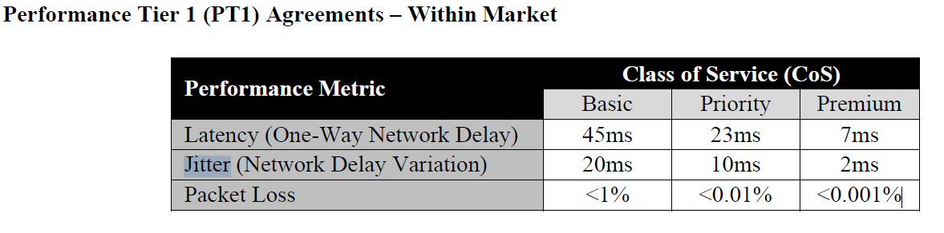
Basic CoS is the best fit at this time. If you can provide the cost difference, that may be something we would consider.
- In review of the RFP document, I did not see Appendix A. Can you please send this to me or advise where I can retrieve it?
DESCRIPTION OF SERVICE | # Circuits | UNIT MONTHLY RECURRING COST/CIRCUIT | MONTHLY TAXES/FEES  Note: Breakdown of taxes/fees must be included separately with vendor’s proposal. Cost should be estimated here. | EXTENDED PRICE  (Unit MRC Price+Taxes/Fees)*Quantity | ONE-TIME NON-RECURRING COST/SPECIAL CONSTRUCTION COST | WILL SERVICE BE AVAILABLE ON JULY 1, 2022?
1 Gbps Dedicated Bandwidth per Building as identified | 3

- What is the lead time for your review process once all responses are received? We will review than as quickly as possible in early January 2022.

- Will your School Board need to approve the winning response, and if so, what is the meeting date when that will occur? Yes, we will look to get approval in the earliest board meeting possible in January or February 2022.
- Please confirm the address of the High School. In the body of the RFP under the Services Requested Section it is 803 East Bishop St, but in the drawing at the end of the RFP it is listed as 830 E Bishop St. All our records indicate the 830 number. Yes, the correct address is 830 East Bishop Street.

