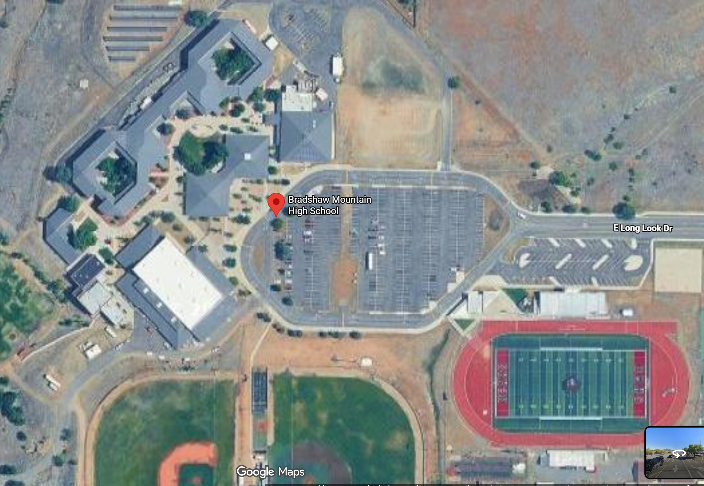
Address of high school: 6000 Longlook Rd, Prescott Valley, AZ 86314
Looking for internet service to the press box at the football field

