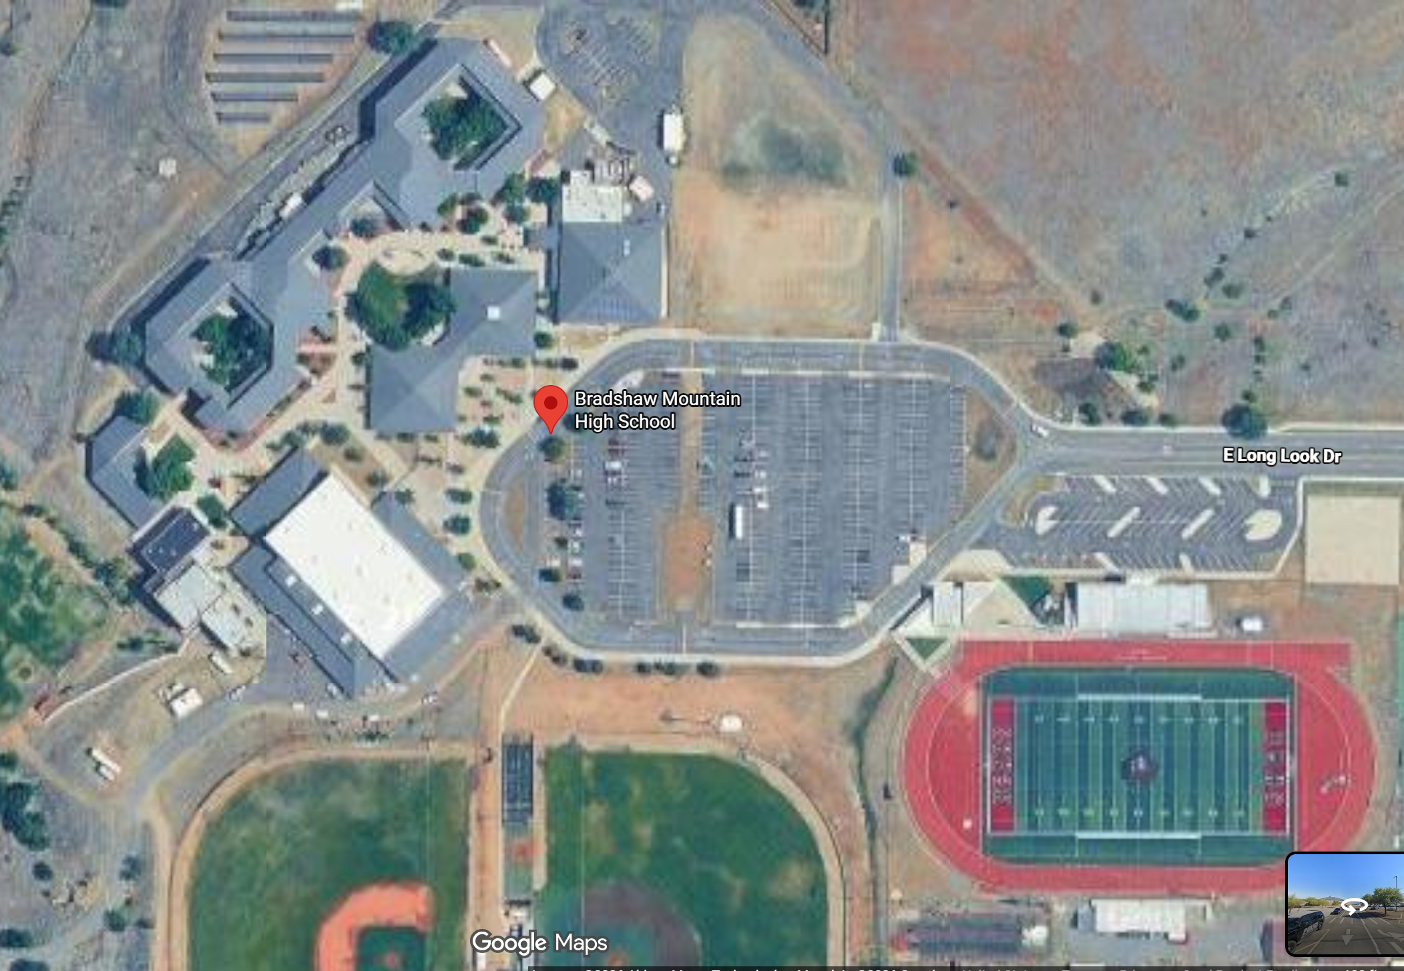
Address of high school: 6000 Longlook Rd, Prescott Valley, AZ 86314
Direct route from nearest IDF would go under asphalt, concrete, and bleachers

