
February 13, 2026
Exhibits and Forms
for the following solicitation types:
CB.CSP.RFP
RFP Informal
RFQ/RFP
RFQ

Exhibits
1 | Insurance Sample of Blanket  (Additional Insurance and/or Waiver of Subrogation)
2 | Certificate of Interested Parties (Form 1295)  Will be requested once a recommendation for award is made.  https://prd.tecprd.ethicsefile.com/TECCertInt/pages/login/certLogin.jsf
3 | Criminal Background Check  Will be requested once a recommendation for award is made (if applicable)
4 | Conflict of Interest Questionnaire (Form CIQ)  Complete, as applicable  https://www.ethics.state.tx.us/forms/conflict/

Forms
1 | (Intentionally Blank)

Exhibit 1

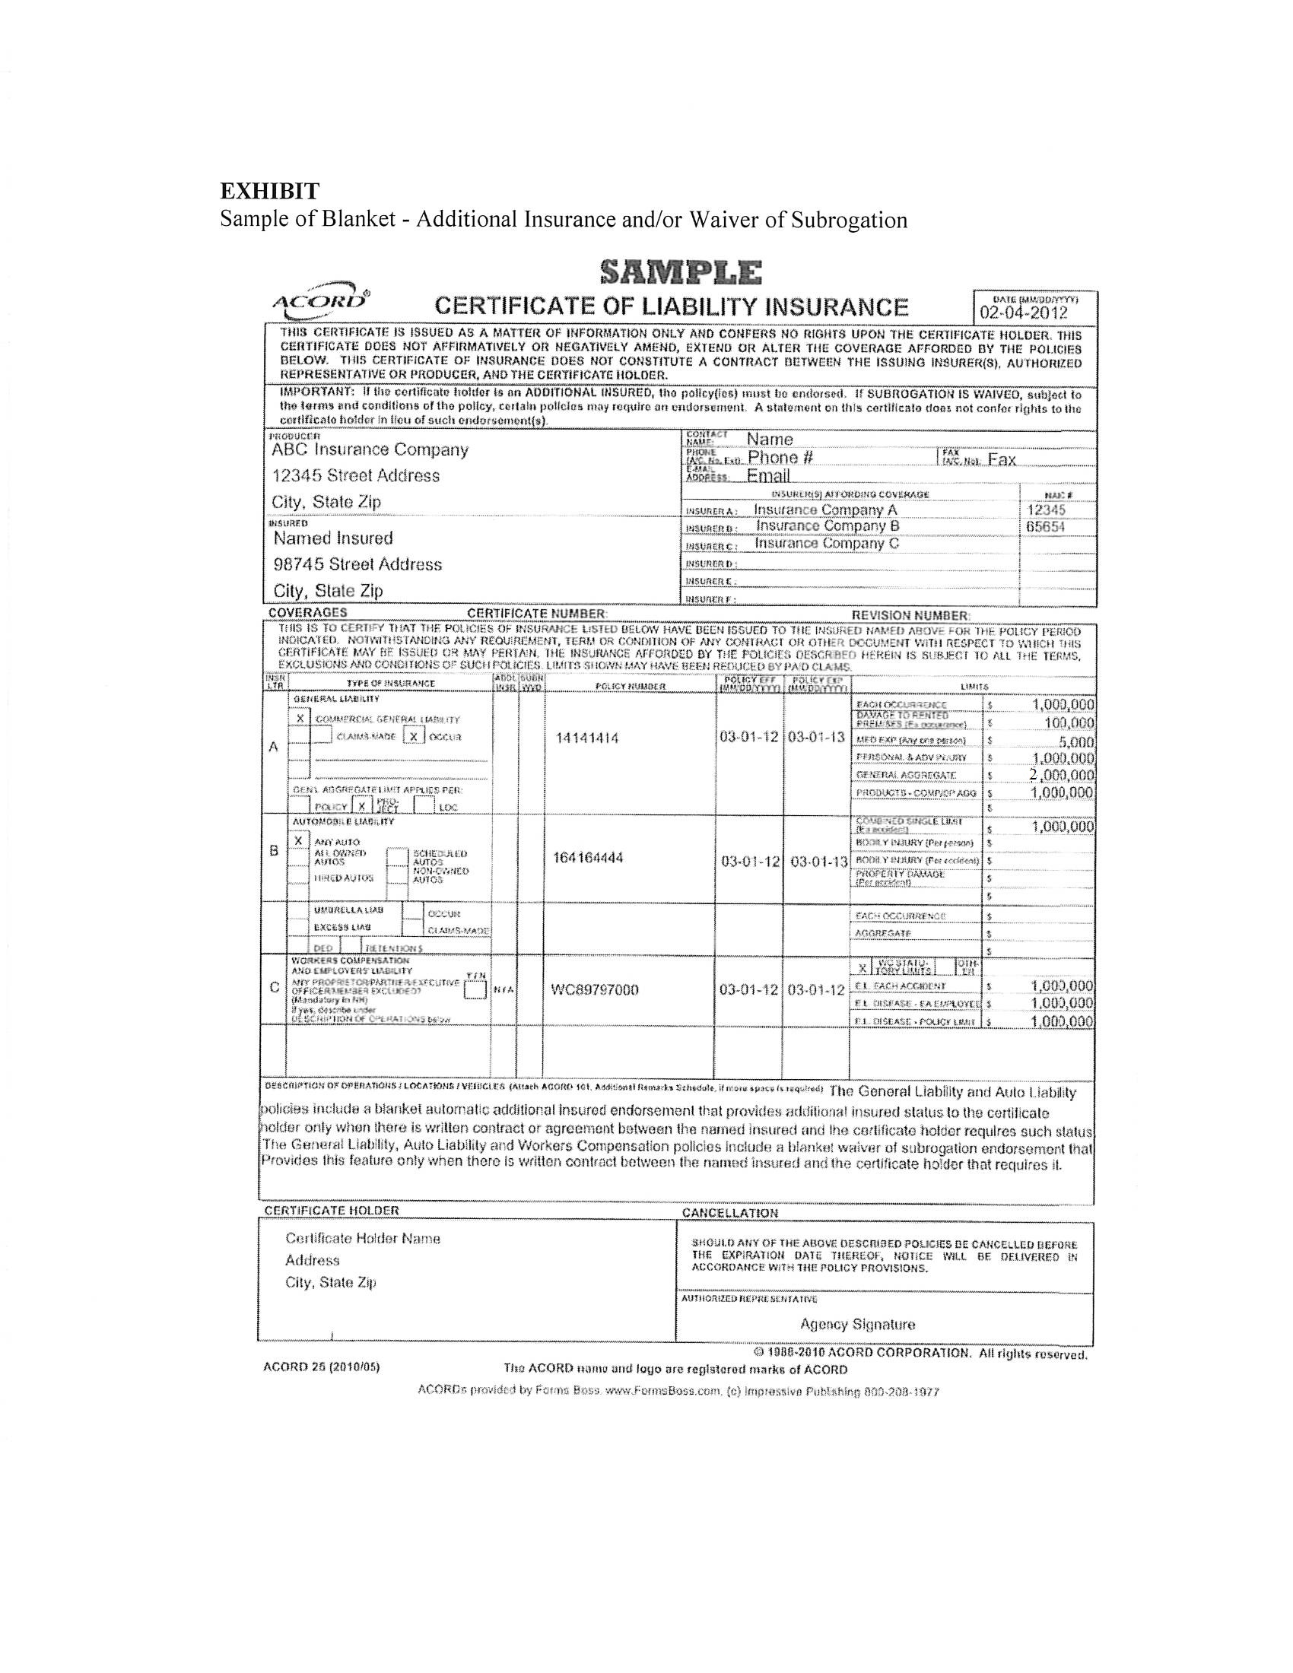

Exhibit 2
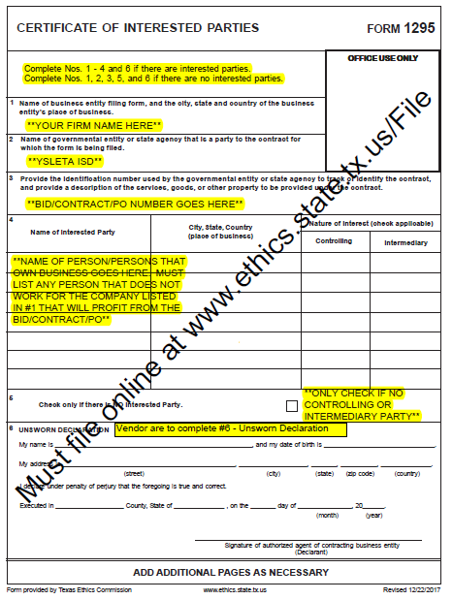

Exhibit 3

