Purpose

The Triad Local School District is seeking installation of five fiber circuits between IT closets and MDFs.

A purchase order to execute this RFP will not be issued until positive E-Rate funding decision has been received.

Technical Requirements

- The following fiber runs are required and are shown in Attachment A:
  - TC02 to MDF - 280ft
  - CTE to MDF - 370ft
  - TC02 to MDF - 250ft
  - MDF to TC03 - 340ft
  - MDF to TC02 - 340ft
- The following are the requirements for each fiber run.
  - The fiber shall be 12 strand single mode, armored, tight buffered, plenum rated
  - Connectors and SFP’s shall be provided and installed to provide transmission bandwidth of 10 Gbps.
  - The estimated length of each fiber run is listed above. However, the vendor is solely responsible for determining the amount of fiber needed.
  - The existing cables connecting the switches shall be de-terminated and abandoned in place.
- All switches shall be reconfigured/reprogrammed to address the increased bandwidth.
- General Requirements
  - All equipment shall be new and shall include manufacturer warranty (three year) that includes next day replacement.
- Installation and Configuration
  - All fiber ends shall be labeled in accordance with a numbering system approved by the district.
  - Cables will be supported above ceiling using "J" type hooks & beam clamps so as no cable "rests upon" any conduit, ductwork or any other devices above ceiling. All cables will be plenum rated, tested and certified. All firewalls will be sleeved, caulked and sealed to NEC and local building regulations.
  - Installation shall include all needed labor, equipment and miscellaneous material (e.g.: conduit and cable supports) needed to comply with this RFP.
  - Installation shall be completed no later than August 15, 2027 or two months from the date of the purchase order (whichever is later).
  - Installation activities shall occur during non-school hours unless prior arrangements are made.
  - Bidders will be required to provide proof of meeting minimum insurance requirements.

Acceptance Requirements

Acceptance will be based on the vendor demonstrating that all fiber circuits and connected switches are operating with a transmission rate of at least 10 Gbps.

Billing Requirements

The school shall not be billed until the above Acceptance Requirements have been met. The invoice shall match the line items of the cost proposal.

Site Visit

An on-site visit is required before our acceptance of your RFP response. Contact Ryan Thompson at 937-826-0040 (thompsonr@triadk12.org) to schedule a site visit.

Vendor Submission Requirements

Vendors wishing to be considered shall provide a proposal that meets the following requirements:
- Submissions will be accepted in electronic format only
- Proposals are to be submitted to grantgermann@erate-edplus.com
- Proposals must be submitted no later than 28 days after the issuance of the Form 470. The applicant reserves the right to reject bids that are received after this date.
- Submissions shall include the following:
  - The bid shall clearly show for Fiber, SFPs and Connectors: Manufacturer, Manufacturer Part#/SKU; Unit Cost. Miscellaneous material such as cable hangers, fire sealant, etc. should be included in the cost of installation.
  - Name of two current or previous clients where fiber installation was part of the service. For each client the following information shall be provided:
- Client Name
- Client Point of Contact
- Contact information (e-mail/phone number)
  - General information about the vendor. The intent is to familiarize the school with the vendor’s background such as the number of employees, annual revenue, the types of clients served by the vendor, and the types of services and technologies provided by the vendor.
  - Required Vendor Information:
- The vendor’s name as listed by USAC
- Vendor’s E-Rate SPIN number or provide documentation that a SPIN has been applied for
- Website address,
- The name and contact information of the individual that is coordinating the vendor’s submission.

Summary

We reserve the right to reject any or all submissions, to extend the submission deadline, and to select a vendor in a manner that provides the best value for the school. We do not expressly state or imply any obligation to reimburse the responding vendors for any expenses in preparing submissions in response to this request.

Questions

Any questions related to this RFP should be addressed by email to the individual that proposals are submitted to no later than one week prior to the Allowable Contract Date.

Attachment A
HS: CTE connects to MDF through TC02 conduit. Ceiling run from CTE to TC02, then existing in-ground conduit from TC02 to MDF.
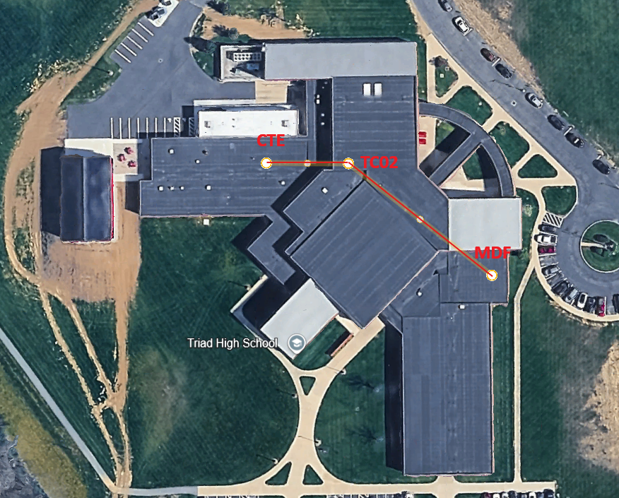

MS: TC02 to MDF - Ceiling run, then conduit down to the basement, then ceiling run.
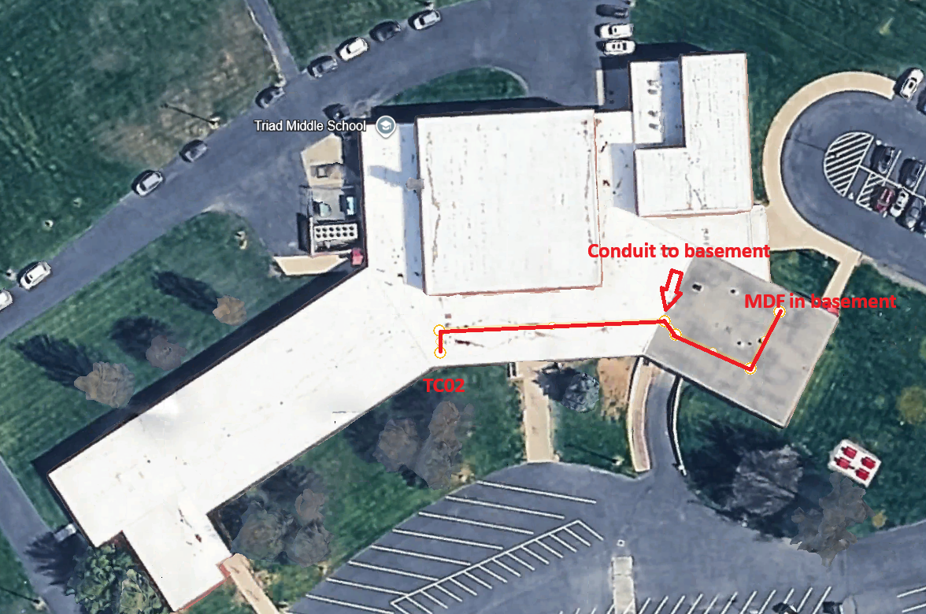

ES: MDF to TC02 and MDF to TC03 - Ceiling run
