Brazosport Independent School District  Business Support Services Setting the standard for educational excellence | 

October 6, 2026

NOTICE

Brazosport Independent School District is interested in receiving proposals from qualified Local Service Providers to provide Dedicated Internet Access Services and Fiber Optic Transport Services per the attached specifications, terms and conditions.

If you have questions regarding this material, or if you require additional information, contact Kelly Lackey, Chief Financial Officer at kelly.lackey@brazosportisd.net or call (979) 730-7113.

Sealed proposals will be received in the Office of the Chief Financial Officer, 301 W. Brazoswood Drive, Clute, Texas, 77531, until 2:00 p.m. Central Time, November 5, 2026, at which time they will be publicly opened. If mailing your proposal, the address is P.O. Drawer Z, Freeport, Texas, 77541. Faxed or e-mailed proposals are not acceptable. You are invited to be present at the proposal opening; however, it is not necessary in order for your proposal to be considered.

The following criteria will be used for awarding contracts:
- Purchase price | 30%
- Reputation of the vendor | 12%
- Quality of goods | 10%
- Extent to which goods meet District’s needs | 10%
- Vendor’s past relationship with District | 10%
- Impact on the ability of District to comply with laws/rules relating to Hubs | 1%
- Long-term cost to the District | 12%
- A contract that is not for goods and services related to telecommunications and information services, building construction and maintenance, or instructional materials, whether the vendor or the vendor’s ultimate parent company or majority owner has its principal place of business in this state or employs at least 500 persons in this state | 0%
- Other relevant factors specifically listed in this RFP including, but not limited to:  - Service level Agreement – 5%  - Proposed Implementation Plan – 5%  - Local Service and Support Team – 5% | 15%

Brazosport Independent School District reserves the right to reject any or all proposals, to waive any technicalities, and to accept the proposal(s) that is determined to be the most favorable to the District.

Responses must be submitted on the forms provided or response may be rejected. Two (2) Hard Copies and Two (2) unchanged electronic copies in a .docx or .pdf format on Two (2) USB thumb drives are required. Only responses received by the date and time specified will be considered.
Faxed responses will not be considered. By submitting a response, Responder certifies to the best of his/her knowledge that all information is true and correct. All responses must be received prior to established deadline at the address listed below.

NOTICE OF NO SUBMISSION FORM

Dear Vendor:

Please check the appropriate box below, complete the remainder of this form and return it by the scheduled date and time:

- Our company cannot provide the products, supplies and /or services listed in this request.
Please MOVE our name and address to the following category(ices) so that we may propose at a later date:
Category(ides): _______________________________________________________

- We have chosen NOT to submit a proposal at this time, but would like to remain on your list for this proposal category. We did not submit a proposal because:
Reason(s): __________________________________________________________

- Please REMOVE our name for all Brazosport ISD list until further notice.
Reason(s): __________________________________________________________

PLEASE RETURN THIS FORM TO:

Brazosport ISD Business Office
Notice of No-Submission - RFP #2027.06 Internet Access Services
P. O. Drawer Z
Freeport, TX 77542

Company Name: ___________________________________________________________

Representative: (please print) _________________________________________________

Address: ___________________________________ Phone: ( ) ___________________

___________________________________

Proposal Opening Date: _______________________

Authorized Signature: _______________________________________________________

Title: ______________________________________ Date: _________________________

Thank you for time and assistance.

VENDORS WHO RESPOND TO THIS INVITATION WITH A COMPLETED PROPOSAL FORM WILL REMAIN ON OUR MAILING LIST. VENDORS MAKING NO RESPONSE AT ALL WILL BE REMOVED FROM THAT LISTING.

SCOPE OF PROPOSAL

The Brazosport Independent School District (“Brazosport ISD”, “BISD” or “District”) is accepting proposals from qualified Local Internet Access service providers to provide Dedicated Internet Access Services and Fiber Optic Transport Services. The purpose of this Request for Proposal (RFP) is to provide a standard from which to evaluate your company’s Internet Access Services as they compare to other providers and as they pertain to the needs of our school district as defined in this document. Due to the increased utilization of the Internet by students, staff, and administration, this RFP is a request for a minimum of 10 Gbps and maximum of 20 Gbps Internet Access port and fiber optic based transport from the service providers point of presence to Brazosport ISD locations as specified in the Pricing Table(s). This RFP does not include any cable or wiring modifications beyond the service providers’ point of demarcation. The district requires this service to be installed and available for service on the Service Start Date specified herein.

SPECIFIC TERMS AND CONDITIONS

- This contract will be awarded to one vendor or mulitple vendors as determined by BISD to provide the best value to the District. BISD reserves the right to negotiate with any or all respondents and accept or reject any and/or all proposals, to waive any formalities and/or irregularities and to award in the best interest of Brazosport ISD.

- Length of Contract: All agreements executed as a result of the responses to this RFP shall be for a three (3) year agreement with two (2) successive one (1) year voluntary extensions. Vendors that do not provide term agreements as specified will be disqualified and any respective proposal will not be evaluated.

- No oral statement of any person shall modify or otherwise change, or affect the terms, conditions, or specifications stated in the resulting contract.

- Final evaluation of this bid will be based on the Texas Educational Code 44.031 (b). Evaluation of pricing will be based on Unit Price value to be submitted on the “SERVICE PRICING SHEET”.

- Timetable - all times listed are Central Time (CT):

Release RFP | October 6, 2026
Deadline for Questions | October 20, 2026 | 2:00 p.m.
Respond to Questions by | October 22, 2026 | 11:59 p.m.
Deadline for Submittal of Proposal | November 5, 2026 | 2:00 p.m.
Service (Contract) Start Date | July 1, 2027

- Communications: All questions received and the corresponding answers will be available to all bidders. No verbal responses will be provided. The deadline for questions about this proposal is noted in the Timetable. The District will not respond to questions after this time and date. Although every effort has been made to provide accurate and up-to-date information, any questions regarding this RFP should be submitted in writing only to Kelly Lackey via e-mail kelly.lackey@brazosportisd.net. Responses to questions will be posted in the form of an addendum to this RFP on the on the USAC website. Vendors are responsible for checking the website(s) for any posted addenda.
- Deadline for Submittal: We must receive your response to this RFP by the time and date noted in the Timetable. Proposals received after this time and date will not be considered. The District is not responsible for unmarked or improperly marked proposals. The District is not responsible for proposals delivered after the scheduled deadline due to the external or internal mail system. The time and date recorded by Brazosport ISD shall be the official time of receipt. The District will not accept fax proposals. Proposals may be withdrawn at any time prior to the due date and time noted in the Timetable. Proposals may not be altered, amended or withdrawn after the due date and time, without the approval of Brazosport ISD.

- Proposal Submittal: Proposals must be submitted on the forms provided. Generic proposals will not be accepted. Proposals must be addressed to Kelly Lackey, Chief Financial Officer, and delivered to 301 W. Brazoswood Drive, Clute, Texas, 77531. The address for mailed proposals is P.O. Drawer Z, Freeport, Texas, 77541. Faxed or electronically transmitted proposals will NOT be accepted. Two (2) Hard Copies and Two (2) unchanged electronic copies in a .docx or .pdf format on Two (2) USB thumb drives must be sealed in an envelope clearly marked on the outside:
RFP #2027.06 – Internet Access Services
Due: November 5, 2026
Time: 2:00 p.m. CT

- Acceptance: BISD reserves the right to accept or reject any or all of the proposals submitted, waive minor technicalities, and accept the offer most advantageous to the District. Contract, to awarded vendors, will be based on the determined “Best Value for the District.”

- Contract shall be put into effect by means of a purchase order(s) executed by the District after proposal has been awarded by the Brazosport ISD Board of Trustees.

- Non-Appropriations: If the District fails to appropriate funds to provide for the annual renewal of a contract, the District may cancel without termination charge. This is provided that the Contractor receives at least 30 days written notice of the termination stating the lack of funding as the reason for the termination.

- Transfer of contract by vendor is prohibited.

- The Brazosport ISD reserves the right to use and duplicate as often as necessary any material that is submitted by the awarded vendor.

- BISD requires that each service provider prepare a separate exceptions page listing ALL exceptions to the specifications within this RFP. Prepare a separate RFP exceptions page even if your company is not listing any exceptions to the specifications within this RFP and notate accordingly. Any proposer not providing a separate exceptions page shall be subject to disqualification.
- Insurance: Copies of the successful contractor's liability insurance and workman's compensation certificates are required. Insurance requirements are listed within this solicitation document.

E-RATE PROJECT DETAILS and SPECIFICATIONS
- Service Providers must distinguish within any pricing documents if a price is a “Special Construction Charge” as defined by the E-Rate program.
- Service provider must include any taxes, surcharges, fees, and any other costs inclusive of construction charges on the pricing sheet.
- Billing cycle will begin on the first day of the month and end on the the last day of the month. Bill will be received no later than seven (7) business days after the end of the month. Service Provider must include a breakdown with detailed charges of all items billed inclusive of any applicable taxes, fees, and surcharges.
- The Universal Service Fund is administered by the Schools and Libraries Division (SLD) of the Universal Service Administrative Company (USAC). This not-for-profit corporation was appointed by the Federal Communications Commission (FCC) to ensure that the benefits of telecommunications services reach students and communities across the country. Service Providers responding to this solicitation must be currently registered with the SLD and must provide the Service Provider Identification Number (SPIN)/FCC 498 ID as assigned by the SLD within the response to this solicitation. For more information, visit the Schools and Libraries Division Website at: https://www.usac.org/e-rate/.
- A portion of the payment for this contract will come from the Schools and Libraries Program (SLD) administered by the Universal Service Administrative Company (USAC). The District is eligible for a certain percentage discount, to be verified by the SLD. The District has historically utilized the Billed Entity Applicant Reimbursement (BEAR) Form (FORM 472) for reimbursement from the School and Libraries Program (SLD). The contracted Service Provider shall acknowledge acceptance of this process. Contracted Service Provider further agrees to fully cooperate with the District in the event the District elects to convert to the Service Provider invoice method during the term of the contract. Contracted Service Provider agrees to provide any Service Provider federal E-Rate data gathering forms pre-populated with billed account numbers and circuit id for the District’s review and certification. All invoices must be detailed by site.
- Service Provider further agrees to submit the “Service Provider Annual Certification” Form for the forthcoming funding year prior to the beginning of the forthcoming funding year.
- Service Provider agrees to resolve within 60 calendar days any formal written billing dispute provided either electronically, or via the United States Postal Service with return receipt requested. Service Provider shall provide the mailing address for formal billing disputes within the response. Service Provider shall provide an escalation list for the billing dispute resolution process. Escalation list shall at a minimum include the Vice-President of your organization responsible for billing disputes. In the event a formal billing dispute is not resolved within 60 days, Service Provider agrees to issue a credit to the District. This credit must appear on the first billing cycle after the expiration of the 60 days allowed for the billing issue resolution process. In the event Service Provider does not provide the credit requested, the District shall subtract said credit from the next month’s bill. Service Provider agrees and accepts that any late payment fees associated with this process shall be waived by Service Provider without demand.
- Interface and Interconnection to the Customer Premise Wiring and Equipment for each service proposed shall be optical.
- All Internet Access Service must provide BGP peering that offers the capability to receive an IPv4 and IPv6 default route as well as a Full Route Table for IPv4 and IPv6. Service Provider shall coordinate with Brazosport ISD and shall configure all equipment to support BGP peering as required by Brazosport ISD.

INTERNET ACCESS SERVICE LEVEL AGREEMENT MINIMUM REQUIREMENTS
The Vendor must meet the following SLA requirements. In addition to the below requirements, the Vendor must submit a full definition of other SLAs that the Vendor offers with a detailed description of what the Vendor measures and how the Vendor performs the measurements required to fulfill the SLA.
Installation SLA
The service will be available for production on the Service Start Date. For every day up to 10 calendar days that the service is not available, the District will receive a 10% credit of the recurring monthly cost of Internet Service. This credit is cumulative until the service is operational. After a total of 10 days of non-service, this credit will increase to 100% of the monthly recurring cost, cumulative. SLA credits should be applied to the the District account on the next month’s billing cycle of occurrence.
Availability SLA
The District and Vendor will acknowledge that the connection is in a working and available condition when the following conditions are met:
The District connections to the Vendor will deliver packets with less than 0.0001% packet loss over a continuous 5-minute period. This is measured from each of the District’s peer site to the Vendor router at the Vendor peering site.
The connection has a latency not exceeding 5 milliseconds measured from the District peering router to the Vendor peering.
Packet Loss SLA
The Vendor will measure and guarantee no more than 0.0001% packet loss across the link from the District to the Vendor. The Vendor will provide the District, a web-based access method to view this tracking or the SLA will be measured by the District router packet loss data.
Latency SLA
The Vendor will measure and guarantee no more than an average of 55 milliseconds round trip time latency across its North American network. The Vendor will provide the District a web-based access method to view this tracking or this SLA will be measured by the District router latency data.
Subscribed Bandwidth SLA
Contracted bandwidth must be guaranteed through the Vendors network to its Peering Sites to other Tier 1 Providers. The Vendor will provide the District, a web-based access method to view this tracking or this SLA will be measured by the District router bandwidth data.
Network Management/Monitoring SLA
Network Management must be available and working 365 days and 24 hours a day. Outside of schedule maintenance windows agreed upon with the District any downtime of the system for over 20 minutes will be considered an SLA violation.
Billing SLA
The Vendor will provide the District an accurate and easy-to- understand invoice within one month of the billing cycle. Invoices must be provided to the District and on paper for processing and bill paying. A sample of the invoice must be provided.
Credits for all Requirements other than Installation
If an SLA is not met the District will receive credit for the amount of time in which the SLA was not met in the current billing cycle. SLA credits should be applied to customer’s account within the next month’s billing cycle of occurrence. The amount charged of credit will be calculated using either of the following formula:
(Minutes not met by the SLA divided total minutes per month) multiplied by the billing cycle charge. If the SLA has not been met for 20% of the billing cycle the entire billing cycle is credited.
QUESTIONNAIRE
Provide answers to the questions below. Use additional sheets if necessary.

- Provide a list of customer service support telephone number(s).
- In a separate sheet, provide a list or organizational chart of your local support management and sales team.
- Define your billing dispute process in detail.
- Provide a list of three (3) references, preferably from similar sized organizations in the Brazosport ISD area, who have used your services within the last three years. Additional references may be required.
- Define your policy, procedures, and cost for IP addresses.
- Include a map of your proposed circuit from your POP to Brazosport ISD’s premises and a map of your Internet Backbone Network.
- Provide a copy of your Internet Service Contract.
- Provide a copy of your Service Level Agreement with your proposal.
- Will you include Internet Access Usage Reports at no additional cost to the customer?
- Describe the level of redundancy within your Internet Access network service offering (Local, Regional, and National).
- In a separate sheet, provide a detailed description for your proposed Point of Demarcation, Interface and Interconnection to the Customer Premise Wiring and Equipment for each service proposed.
- Do you provide access to customer support on a 7 x 24 x 365 basis?
- List any additional non-recurring and monthly recurring charges for IP addresses.
- Describe your peering arrangement with other National Internet IP Backbone Networks.
- Describe your peering arrangement with “Big Cloud” providers, including but not limited to AWS, Google and Microsoft.
- Describe your peering relationship to Tier 1 providers.
- Provide information of your DDoS (Distributed Denial of Service) service offering.

PRICING SHEETS
Vendors shall propose Dedicated Internet Access Port and Fiber Optic Transport Services for a three (3) year agreement with two (2) successive one (1) year voluntary extensions. Provide the requested information for each of the Tables described below.

In Table 1 provide the Service Provider Information.
In Table 2 provide the following as applicable:
- Non-Recurring Charge (NRC) if any for each Service Location and Term identified.
- Monthly Recurring Charge (MRC) for each Service Location and Term identified.
- List any Special Construction Charge (SCC) if any for each Service Location.
- List separately any and all Taxes, Fees, Surcharges, and Construction Charges not included in the Pricing Table.

Table 1 Service Provider Information
Service Provider Name
Main Address
Remittance Address
Contact Name for Proposal
Telephone Number
Fax Number
USAC SPIN NO./FCC 498ID
Primary Scope of Business
Point of Presence Location
Name of Facility
Address
City, State Zip

Table 2 Internet Access Port and Transport Pricing
Provide Port and Transport pricing plans from your company for a three (3) year agreement with two (2) voluntary one-year extensions based on the following table.
Internet Access Port and Transport
Transport is from service provider’s point of presence to the following location:

Brazosport Technology Resource Center 17028562
221 Lakeview Drive
Clute, TX 77531
Bandwidth | NRC | MRC  Three Year  Term | MRC  For Each One-Year Extension (optional) | SCC
10 Gbps
20 Gbps

In the space below list any additional Taxes, Fees, Surcharges, Construction Charges, etc. not included above (add lines as needed):
Detailed Description | Amount

EXCEPTIONS

Include as a separate page listing ALL exceptions to the specifications within this RFP. Refer to Specific Terms and Conditions.

Proposal Acknowledgement
By signing, the officer certifies that it has read, understands, and agrees to the requirements of the specifications and all other provisions of this solicitation.

The signature below is made by an authorized agent or vendor, and it affirms that this company, corporation, firm, partnership, or individual has not prepared this proposal in collusion with any other proposer(s) and that the contents of this proposal as to prices, terms, and conditions of said proposal have not been communicated by the signed person nor any employee or agent to any other person engaged in this type of business prior to official opening of the proposal.

Signature above affirms receipt and understanding of all Notices and Instructions, Specifications, Terms and Conditions, Proposal Form, Scope, Contract Clauses, Representations and Certifications, Felony Conviction Requirements, and all documents pertaining to this proposal and attached as reference, if applicable. Vendor agrees to abide by all conditions and any negotiations that are a part of this RFP. Negotiated conditions will be in writing, attached to the official proposal documents.

Vendor represents that to the best of its knowledge the proposer is not indebted to the District. Indebtedness to the District shall be basis for non-award and/or cancellation of any award or acceptance.

Vendor certifies that no local, state or federal suspension or debarment is in place as of the date of the RFP Response Submittal.

COMPANY NAME

ADDRESS

CONTACT PERSON (PRINTED OR TYPED) TITLE TELEPHONE EMAIL

AUTHORIZED SIGNER (PRINTED OR TYPED) TITLE TELEPHONE EMAIL

AUTHORIZED SIGNER (SIGNATURE)
  - GENERAL TERMS AND CONDITIONS FOR PROPOSALS

  - APPLICABILITY – These conditions are applicable and form a part of the contract documents in each equipment and/or service contract and a part of the terms of each purchase order for items of equipment and/or service included in the specifications and proposal forms issued herewith.

  - WITHDRAWAL OF PROPOSALS will not be allowed for a period of 90 days following the proposal opening.

  - SPECIFICATIONS may be those developed by the Using Department or by the Manufacturer to represent items of regularly manufactured products.

    - DISTRICT SPECIFICATIONS have been developed by the Using Department to show minimal standard as to the usage, materials, and contents based on their needs.

    - MANUFACTURER’S SPECIFICATIONS (Design Guide), when used by the District, are to be considered informative to give the offeror information as to the type and kind requested. Proposals on any reputable manufacturers regularly produced product of such items similar and substantially equivalent will be considered.

  - QUESTIONS concerning this proposal shall be addressed to the Chief Financial Officer, Brazosport Independent School District.

  - PROPOSALS SHALL BE SUBMITTED ON THESE FORMS. Deviation to any Conditions and/or Specifications shall be conspicuously noted in writing by the offeror and shall be included with the proposal.

  - SEALED PROPOSALS ONLY ARE ACCEPTABLE. FAXED PROPOSALS will not be accepted by BISD since the fax process does not provide for the delivery of a sealed proposal.

  - REQUIRED ADDENDA, if required, will be issued by BISD Business Services to all those known to have received a complete set of proposal documents.

  - QUANTITIES REQUIRED are substantially correct. The District reserves the right to purchase additional quantities above that stated at the same unit price unless otherwise specified by the offeror.

  - DELIVERIES required in this proposal shall be freight prepaid, F.O.B. destination and proposal prices shall include all freight and delivery charges.

  - WARRANTY CONDITIONS for all supplies and/or equipment shall be considered manufacturer’s minimum standard warranty unless otherwise agreed to in writing. Offeror shall be an authorized dealer, distributor of manufacturer for the product. All equipment proposed shall be new unless clearly stated in writing.

  - SAMPLES, when called for, shall be submitted with the proposal per instructions set forth in the Special Terms and Conditions.

    - ADDITIONAL SAMPLES needed for a proposal to be evaluated property shall be delivered within (5) working days form the time the vendor is notified by the BISD.

    - SAMPLE ITEMS from the successful offeror may be retained for the purpose of determining that the quality and workmanship of the delivered items are comparable to the sample.

  - THOSE WHO DO NOT PROPOSE are requested to notify the Brazosport Independent School District Office of the Chief Financial Officer the in writing if they wish to receive future proposals. Failure to do so may result in their being deleted from our prospective offeror list.

  - EVALUATION OF PROPOSALS takes into account the following considerations: price, quality, suitability for the intended use, probability of continuous availability, vendor’s service, safety record, and date of proposed delivery and placement. It is not the policy of the Brazosport Independent School District to purchase on the basis of low proposals alone.

  - DISCLOSURES

    - By signing this proposal, an offeror affirms that he/she has not given, offered to give, nor intends to give at any time hereafter any economic opportunity, future employment, gift loan, gratuity, special discount, trip, favor or service to a public servant in connection with proposal submitted.

    - OFFEROR SHALL NOTE any and all relationships that might be a conflict of interest and include such information with the proposal.

    - By signing this proposal, an offeror affirms that, to the best of his/her knowledge, the proposal has been arrived at independently, and is submitted without collusion with anyone to obtain information or gain any favoritism that would in any way limit competition or give them an unfair advantage over other offerors in the award of this proposal.

  - FUNDING OUT CLAUSE. Any/all contracts exceeding one (1) year will require a standard “funding out” clause.

“A contract for the acquisition, including lease, of real or personal property is a commitment of the District’s current revenue only, provided the contract contains either or both of the following portions:
- Retains to the District the continuing right to terminate the contract at the expiration of each budget period during the term of the contract.
- Is conditioned on a best efforts attempt by the District to obtain and appropriate funds for payment of the contract."

  - ALL CONTRACTS AND AGREEMENTS between Merchants (Offerors) and Brazosport Independent School District shall strictly adhere to the statutes as set forth in the Uniform Commercial Code as last amended in 1995 by the American Law Institute in the National Conference of Commissioners on Uniform State Laws. Reference: Uniform Commercial Code, Fourteenth Edition, 1995 Official Text.

  - CONTRACTS FOR PURCHASE will be put into effect by means of a purchase order(s) executed by the Chief Financial Officer after proposals have been awarded.

    - Any additional agreements/contracts to be signed by BISD shall be included with the proposal.

    - Prices for all goods and/or services shall be negotiated to a firm amount for the duration of this contract or as agreed to in terms of time frame.

    - Tax Exemption: BISD is exempt from payment of taxes under Chapter 20, Title 122A, Revised Civil Statutes of Texas, for the purchase of tangible personal property.

  - ASSIGNMENTS AND SUBCONTRACTING: No part of this order may be assigned or subcontracted without the prior written approval of BISD. Payment can only be made to the awarded Supplier.

Additional Terms and Special Conditions

EQUAL OPPORTUNITY
Vendors shall not discriminate against any employee or applicant for employment because of race, religion, color, sex, or national origin. Bidder certifies that the company complies with Executive Order 11246, entitled “Equal Employment Opportunity”, as amended by Executive Order 11275 and as supplemented in Department of Labor Regulations.

NON-COLLUSIVE BIDDING CERTIFICATE
By submission of this proposal, the Bidder certifies that:
- This proposal has been independently arrived at without collusion with any other Bidder or with any Competitor;
- This proposal has not been knowingly disclosed and will not be knowingly disclosed, prior to the opening of proposals for this project, to any other Bidder, Competitor or potential Competitor;
- No attempt has been or will be made to induce any other person, partnership, or corporation to submit or not to submit a proposal;
- The person signing this bid or proposal certifies that he has fully informed himself regarding the accuracy of the statements contained in this certification, and under the penalties being applicable to the Bidder as well as to the person signing in its behalf.

FELONY CONVICTION NOTIFICATION
Texas Education Code Section 44.034. Notification of Criminal History Contractor.
- A person or business entity that enters into a contract with a school district must give advance notice to the district if the person or an owner or operator of the business entity has been convicted of a felony. This notice must include a general description of the conduct resulting in the conviction of a felony.
Vendor Response (initial):
________ My firm is not owned or operated by anyone who has been convicted of a felony
________ See attached statement
- A school district may terminate a contract with a person or business entity if the district determines that the person or business entity failed to give notice as required by Subsection (1) or misrepresented the conduct resulting in the conviction. This district must compensate the person or business entity for services performed before the termination of the contract.
- This section does not apply to a publicly held corporation.
Vendor Response (initial) if Subsection (3) applies: __________

DISCLOSURE OF INTERESTED PARTIES (Form 1295)
In 2015, the Texas Legislature adopted House Bill 1295, which added section 2252.908 of the Government Code. The law states that a governmental entity or state agency may not enter into certain contracts with a business entity unless the business entity submits a disclosure of interested parties to the governmental entity or state agency at the time the business entity submits the signed contract to the governmental entity or state agency. The law applies only to a contract of a governmental entity or state agency that either (1) requires an action or vote by the governing body of the entity or agency before the contract may be signed or (2) has a value of at least $1 million. The disclosure requirement applies to a contract entered into on or after January 1, 2016.

Signature below certifies to all three sections above.

Signature: ____________________________ Date: ________________
Printed Name: ____________________________
Company Name: ____________________________
Telephone Number: ____________________________
Email Address ____________________________

CONFLICT OF INTEREST
Effective May 25, 2007, Section 176.006, Local Government Code requires that persons or agents who enter or seek to enter into a contract with a local government entity shall file a completed conflict of interest questionnaire, if they have an employment or other business relationship with an officer of family member of an officer of the entity or have given the officer or family member gifts in excess of $250 aggregated over a twelve-month period. Failure to disclose this information is a Class C misdemeanor. This requirement will be addressed in all requests for proposals.

VISITOR REGISTRY SYSTEM
Pursuant to Section 38.022 of the Texas Education code, vendors must present a valid state or government-issued photo ID before access into the school is granted. This ID may be scanned into a registered sex offender database; any vendor found to be an offender will be denied access into the school. Local law enforcement will be contacted should this occur.

CLEAN AIR & WATER ACT
I certify that my company is in compliance with all applicable standards, orders or regulations issued pursuant to the Clean Air Act of 1970, as amended (42 U.S.C. 1857(h), Section 508 of the Clean Water Act, as amended (33 U.S.C. 1368), Executive Order 117389 and Environmental Protection Agency Regulation, 40 CFR Part 15 as required under OMB circular A-102, Attachment O, Paragraph 14 (1) regarding reporting violations to the grantor agency and to the United States Environmental Protection Agency Assistant Administrator for the Enforcement.

INDEMNIFICATION
Successful vendors shall indemnify and save harmless Brazosport ISD from and against any and all claims, demands, damages, lawsuits, expenses, costs, liabilities, injuries, liens, and causes of action arising out of, resulting from, or in any manner connected with the performance of the work hereunder, to the extent caused in whole or in part by the negligent acts or omissions of the vendor, subcontractor, anyone directly or indirectly employed by them or anyone for whose acts they may be liable, regardless of whether or not such claim, damage, loss or expense is caused in part by the partial, but not sole, negligence of Brazosport ISD. The contractor herby agrees to defend any and all such actions brought against Brazosport ISD for any and all expenditures, or expenses, including but not limited to court costs and attorney fees, made or incurred by Brazosport ISD and/or by reason of any such suit or suits.

DEBARMENT AND SUSPENSION
Pursuant to Federal Rule (H), when federal funds are expended by Brazosport ISD, the vendor certifies that during the term of an award for all contracts by Brazosport ISD resulting from this procurement process, the vendor certifies that neither it nor its principals is presently debarred, suspended, proposed for debarment, declared ineligible, or voluntarily excluded for participation by any federal department or agency.

Signature below certifies to all four sections above.

Signature: ____________________________ Date: ________________
Printed Name: ____________________________
Company Name: ____________________________
Telephone Number: ____________________________
Email Address ____________________________

INSURANCE REQUIREMENTS
All vendors who perform contracted services for Brazosport ISD are required to supply proof of insurance in accordance with the following schedule prior to the start of the project. The District reserves the right to require higher limits of coverage depending on the size, scope, and nature of a contract. Brazosport ISD must be named as an additional insured in liability policies with a waiver of subrogation in favor of the District for workers’ compensation policy.
Property Damage Liability: $ 100,000 each accident
Property Damage Aggregate: $ 500,000 each accident
Bodily Injury Liability: $ 500,000 each occurrence
Automobile Liability Bodily Injury: $ 500,000 each occurrence
Total Liability: $1,000,000 each occurrence or aggregate

TERMS OF PROPOSAL
All agreements executed as a result of the responses to this RFP shall be for a three (3) year agreement with two (2) successive one (1) year voluntary extensions. Vendors that do not provide term agreements as specified will be disqualified and any respective proposal will not be evaluated.

EVALUATION CRITERIA
It is not the policy of Brazosport ISD to award contracts on the basis of low price alone. To determine the award of this proposal, the District shall consider the following, as provided in the Texas Education Code 44.031(b).
- Purchase price.
- The reputation of the vendor and of the vendor’s goods and services.
- The quality of the vendor’s goods or services.
- The extent to which the goods or services meet the District’s needs.
- The vendor’s past relationship with the District.
- The impact on the ability of the District to comply with laws relating to historically underutilized businesses.
- The total long-term cost to the District to acquire the goods or services.
- For a contract that is not for goods and services related to telecommunications and information services, building construction and maintenance, or instructional materials, whether the vendor or the vendor’s ultimate parent company or majority owner has its principal place of business in this state or employs at least 500 persons in this state.
- Other

Signature below certifies to all three sections above.

Signature: ____________________________ Date: ________________
Printed Name: ____________________________
Company Name: ____________________________
Telephone Number: ____________________________
Email Address ____________________________

WARRANTY
Vendor warrants that the services and products sold to the District shall conform to the specifications and standards of this proposal as well as any/all national, state, and local codes. Vendor also represents that the goods, materials, supplies, or components are new, not used or reconditioned, and are not of such age or so deteriorated as to impair their usefulness or safety and that they are of current manufacture. In the event the services or products do not conform to the standards, the District may request a correction at the Vendor’s expense.

GENERAL INFORMATION REQUESTED

- Is your firm’s principal place of business located within the boundaries of the District?
_________________

- How many years has your firm been doing business?
_________________

- How many years has your firm been doing business with Brazosport ISD?
_________________

- Within the past five years, has an officer or partner of your organization failed to complete a contract? If yes, please explain.
______________________________________________________________

- Please list 3 Reference:
Name of Firm Representative Telephone

1. ______________________ _____________________ ______________

2. ______________________ _____________________ ______________

3. ______________________ _____________________ ______________

SUBMISSION OF PROPOSALS
All proposals must be received no later than 2:00 p.m. on November 5, 2026. All proposals must be addressed to one of the following:

FedEx/UPS/other US Mail
Brazosport Independent School District Brazosport Independent School District
Attn: Kelly Lackey, Chief Financial Officer Attn: Kelly Lackey, Chief Financial Officer
301 W. Brazoswood Dr. P. O. Drawer Z
Clute, Texas 77531 Freeport, Texas 77541

All proposals must be in an envelope clearly marked RFP #2027.06 – Internet Access Services Due: November 5, 2026 2:00 p.m. No proposal that is received by BISD after the due date and time will be considered for award. Any late proposals will be returned unopened to the vendor upon request only. The District is not responsible for mail, courier or other delivery methods in transit time or non-delivery. Faxed or electronically transmitted proposals will NOT be accepted.

NOTICE OF TEXAS ETHICS COMMISSION HOUSE BILL 1295

As of January 1, 2016, a new state policy was implemented that affects all proposals which are awarded by our board of Trustees. HB1295 basically states the following.

House Bill 1295 amended the Texas Government Code by adding Section 2252.908, the Disclosure of Interested Parties. Under this Section 2252.908, Brazosport ISD is prohibited from entering into a contract resulting from this RFP with a business entity unless the business entity submits a Disclosure of Interested Parties (Form 1295) to the District at the time business entity submits the signed contract. The Texas Ethics Commission has adopted rules requiring the business entity to file Form 1295 electronically with the Texas Ethics Commission.

The Texas Ethics Commission Website address for this form is:
https://www.ethics.state.tx.us/whatsnew/elf_info_form1295.htm

Instructions for Vendor’s Compliance with HB1295

VENDOR’S Responsibility to compliance:
As a “business entity,” all vendors must electronically complete, then print, sign and submit Form 1295 with their proposal or contracts even if there are no conflicting interested parties within the district.

1) Go to the Ethics Commission Website to register and complete the form.
Proposers must complete the filing application Form 1295 electronically with the Texas Ethics Commission using the online filing application,

2) Proposers must print a copy of the completed form, which will include a certification of filing containing a unique certification number, assigned by their website, in the upper right hand corner of the document.

3) The Form 1295 must be signed by an authorized agent of the business entity.

4) Send a copy of the form with your proposal documents.

Brazosport ISD’s Responsibility to Compliance:
1) Once received, Brazosport ISD must acknowledge the receipt of the filed Form 1295 by notifying the Texas Ethics Commission of the receipt of the filed Form 1295 no later than the 30th day after the date the contract binds all parties to the contract.

2) After Brazosport ISD acknowledges the Form 1295, the Texas Ethics Commission will post the completed Form 1295 to its website within seven business days after receiving notice from Brazosport ISD.

3) The completed Form 1295 with the certification of filing will be filed with your completed proposal or contract that was provided to the district for board award.

4) We will then provide vendor numbers to staff for issuance of purchase order.

Additional information to help clarify HB1295:

- Should you have questions and require additional information, please contact the Texas Ethics Commission at 512-463-5800.
- For questions on submitting Form 1295, contact Cynthia Roye at croye@brazosportisd.net or by phone at 979-730-7048
Contracts exempt from the Form 1295 filing requirement under the amended law
Certain contracts are excluded from the disclosure requirement. For contract entered into on or after January 1, 2018, the exclusions that are likely to apply to school district include a contract with (1) a publicly traded business entity, including a wholly owned subsidiary of the business entity; (2) an electric utility, as defined by Section 31.002, Utilities Code; and (3) a contract with a gas utility, as defined by Section 121.001, Utilities Code. Tex. Gov’t Code § 2252.908(c) (4)-(6).

[Sample of FORM 1295 on the next page]
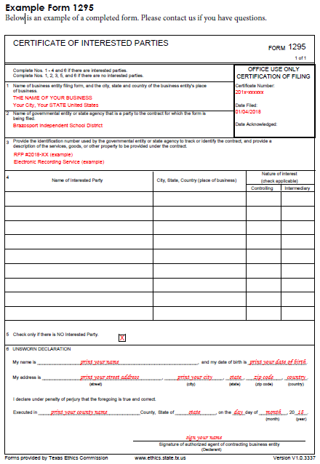
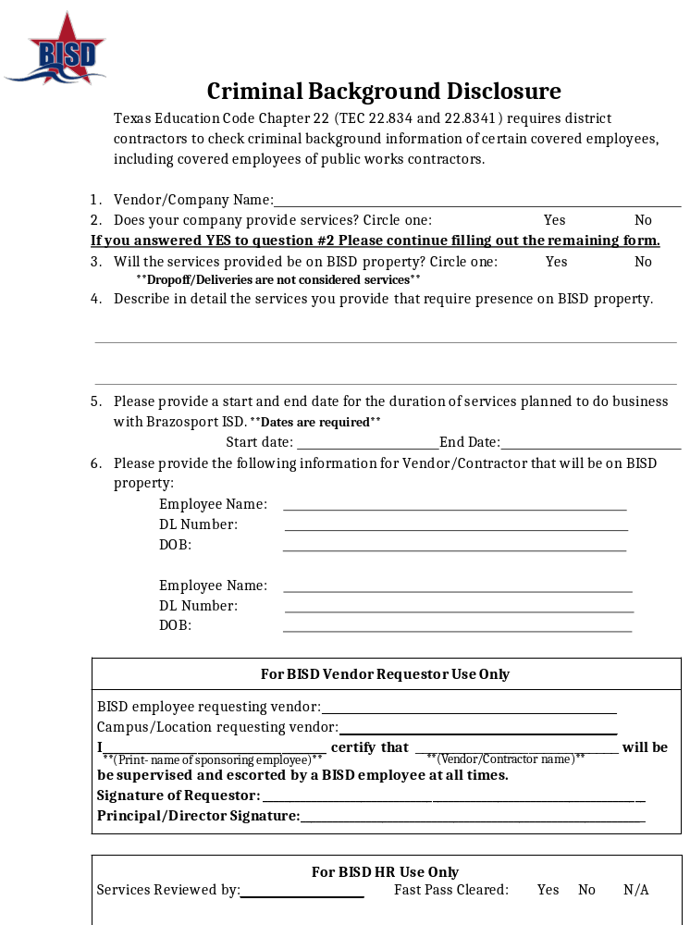
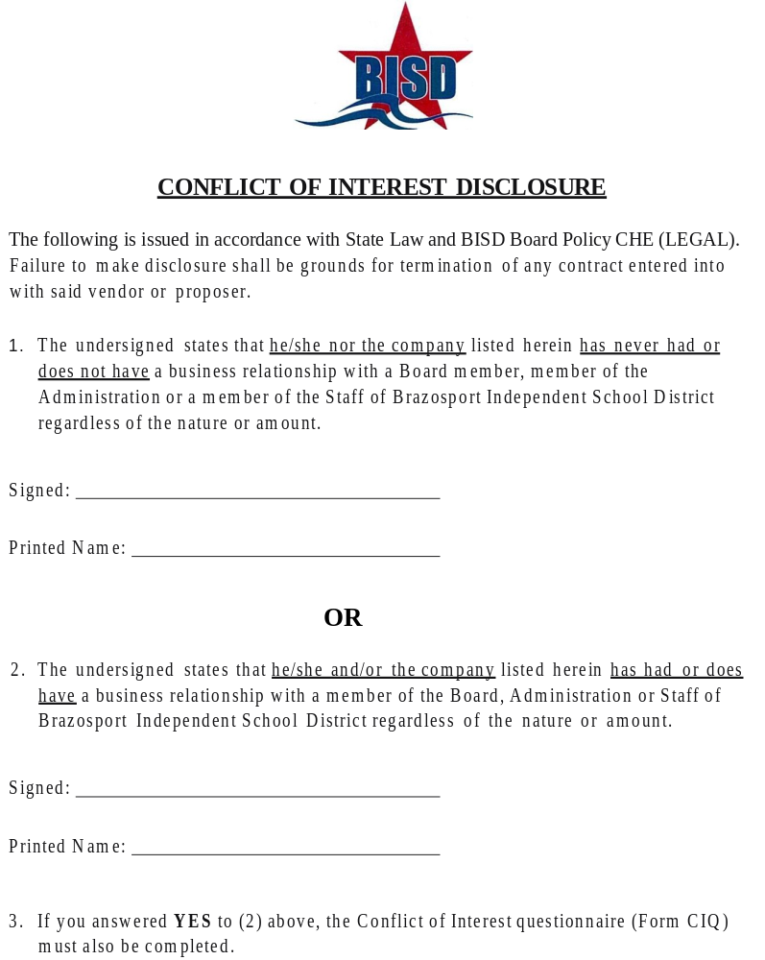
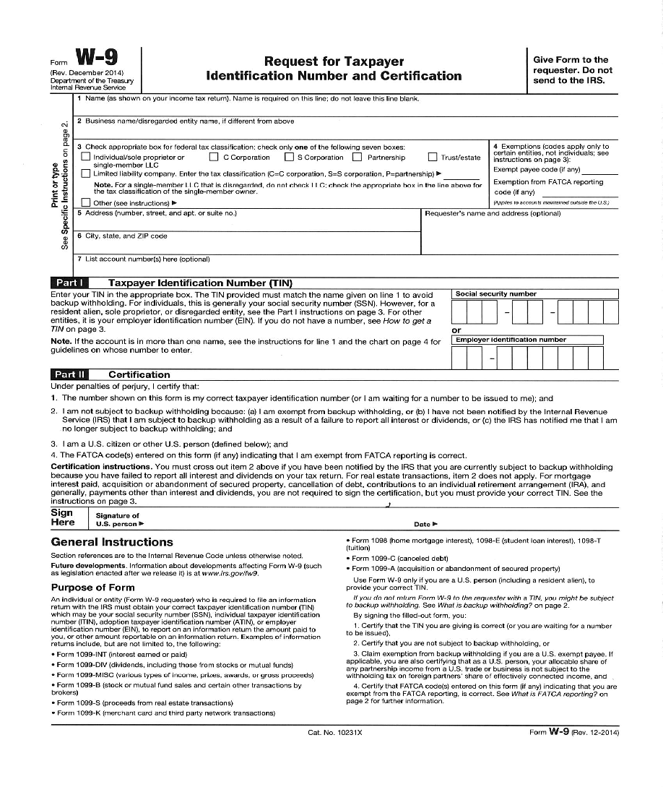

Extension Price is Optional as selected by Brazosport ISD. Auto renewal language will not be allowed in the final contract.
Service Providers who are charging a “Special Construction Charge” will be required to provide additional information in the Special Construction of New Fiber section SCC Cost per Foot spreadsheet.

