Bonneville Joint School District 93
RFP Title: Tellabs support and licensing
1. Introduction
Bonneville Joint School District 93 is seeking a qualified vendor to provide Tellabs equipment support and Panorama software licensing (or compatible equivalent). The district is interested in securing a three-year contract with 2 optional one-year renewals with the selected vendor. The purpose of this RFP is to solicit proposals from interested vendors for the provision of Tellabs support and licensing that meets the District's specific requirements and objectives.
2. Scope of Work
- Tellabs Panorama software Licensing (or equivalnet): The vendor will provide licensing and support for Tellabs OLAN, covering Tellabs an OLT 1150 and all ONT devices. ONT models include ONT140W, ONT140C, ONT180C, and ONT205, (577 total) or equivalent within the District's network infrastructure. (See items 1 & 2 below)
- Installation and Configuration: The vendor will be responsible for the installation, configuration, and ongoing management of the licensing.
- Technical Support: The vendor will provide technical support for the licensing, including troubleshooting, problem resolution, and maintenance.
3. Proposal Requirements
- Vendor Information: Provide detailed information about your company, including experience, qualifications, and references.
- Licensing Details: Specify the exact licensing products and features that will be provided to meet the District's requirements.
- Pricing and Payment Terms: Outline your pricing structure, payment terms, and any additional fees or charges. All ineligible services should be identified and priced separately.
- Implementation Timeline: Provide a detailed implementation plan, including estimated timelines for installation, configuration, and training.
- Technical Support Services: Describe the level of technical support that will be provided, including response times, escalation procedures, and remote access capabilities.
- Warranty and Maintenance: Specify the warranty and maintenance terms for the licensing and related equipment Tellabs equipment.
- References: Provide references from previous clients who have similar experiences with your company.

4. Evaluation Criteria
Proposals will be evaluated based on the following criteria:
- Price – The price of eligible goods and services will be the highest weighted factor. The Owner will be evaluating price based on the eligible monthly and eligible “one-time” costs.
- Other Cost Factors – The Owner will evaluate the other cost factors based on, but not limited to, the cost of service for “ineligible” goods and services, the cost of early termination for existing contract(s), any additional costs incurred by the Owner for the start of the proposed service.
- Accuracy of Bid Response: The vendor's ability to accurately address all RFP requirements and provide a comprehensive response.
- Experience and References: The vendor's experience with Tellabs equipment and installation.
- Qualifications/Technical Expertise/Ability: The vendor's ability to meet the District's technical requirements. The level of technical support offered and the responsiveness of the vendor.

5. Additional Information
All bids, whether hard copy or email, must be received no later than {30 days from posting} at 4:00 PM MT.
For any questions or clarifications regarding this RFP, please contact:
Gordon Howard howardg@d93mail.com

The vendor will provide licensing and support for Tellabs OLAN, covering Tellabs an OLT 1150 and all ONT devices. ONT models include ONT140W, ONT140C, ONT180C, and ONT205, (577 total) or equivalent within the District's network infrastructure. (See items 1 & 2 below)
Item 1 - or equivalent and compatible solutions
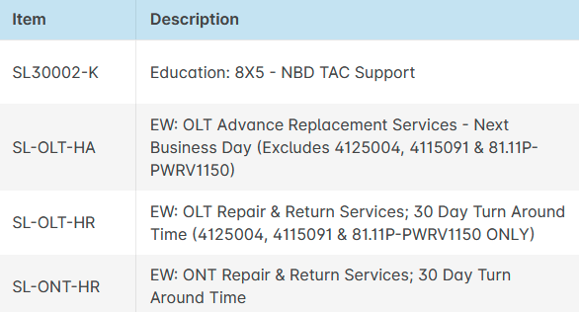
Item 2 - or equivalent and compatible solutions
