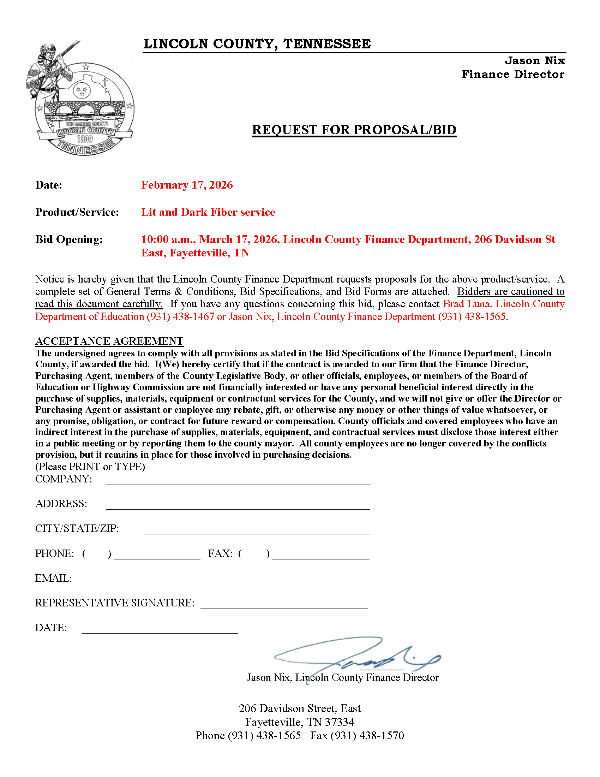
GENERAL TERMS AND CONDITIONS

PRODUCT OR SERVICE: Lit and/or Dark Fiber service

DEADLINE FOR RECEIVING BIDS: 10:00 a.m., March 17, 2026

1. Bid Format: SEALED BID. Bid forms must be completed in ink or typed, signed in ink, and free from alterations. FAXED BIDS will not be accepted. BIDS MUST BE CLEARLY MARKED ON OUTSIDE OF ENVELOPE WITH “RFP-WAN 26-31” AND OPENING DATE. Lincoln County is not responsible for the confidentiality of bids inadvertently opened during mailing or receipt thereof. Unsealed bids will not be accepted. Any bid received after time and date indicated above will not be considered.

2. Bid Opening: Unless otherwise stated, bids will be opened publicly and read aloud in the Lincoln County Finance Department, 206 Davidson Street East , Fayetteville, TN 37334 on above stated deadline date.

3. Prospective bidders who are authorized, licensed, and capable are requested to submit bids to provide these needed product(s) and/or service(s) for Lincoln County.

4. It shall be the responsibility of the bidder to submit a bid response that complies with the conditions and specifications of the Request for Bid; Policies and Procedures of Lincoln County, applicable laws of the State of Tennessee, and any other applicable laws, regulations, and requirements.

5. It is the intent of this Request for Bid to secure competitive bid responses. The specifications herein are intended only to indicate the general character, style and quality of the item(s) desired. Bidders are encouraged to propose and offer equipment, supplies, or service either as specified herein, or equal to or better in character, style, and quality to items specified herein. Any exceptions to the specifications must be listed on a separate sheet entitled “Exceptions to Specifications.” Bids taking complete or major exceptions will not be accepted.

6. Bidders agree that other parts and services not specified but which might be needed by Lincoln County in fulfillment of the procurement transaction will be made available at prices equal to or less than the lowest price charged other non-profit or governmental organizations.

7. Lincoln County reserves the right to increase or decrease quantities to be purchased over the life of this agreement and to reject any or all bids or any part of any bid, to waive technicalities, or to accept other than the bid with the lowest cost meeting all specifications. Lincoln County may accept any bid deemed in the best interest of the County, whether or not it is the low bid.

8. Any bid submitted should be for the total cost to Lincoln County.

9. Payment will be made within thirty (30) days of the date vendor bill is received and signed by an authorized County representative.

10. Evaluation and award of bids will be made to one bidder who will meet the requirements of the Finance Department of Lincoln County.

11. IMPORTANT! Bidder must use bid form included in this bid package, and bid must be signed by authorized representative of company/business placing bid at time bid is received by Lincoln County. If not, bid will be rejected at time of bid opening.

Lincoln County does not discriminate on the basis of race, color, national origin, age or disability. All bidders, contractors, and sub-contractors shall comply with this non-discrimination statement.

By submission of this bid, each bidder and each person signing on behalf of any bidder certifies, and in the case of a joint bid each party thereto certifies as to its own organization, under penalty of perjury, that to the best of its knowledge and belief that each bidder is not on the list created pursuant to §12-12-106.

RFP-WAN-26-31

- Introduction background and overview:
The intent of this RFP is to request Wide Area Network (WAN) services for the Lincoln County School District, referred to as District throughout this RFP. The District currently has 6 schools, 4 administrative facilities and one multi-use Pre-k/alternative school/administrative facility. The District is requesting pricing for Lit and/or Dark Fiber Services as per E-rate rules to compare the short term and long term cost of these services. However, responders to this RFP may also provide responses to additional services and or goods that will complement and/or supplement the services requested through this RFP as an additional Attachment.
The awarded contract(s) will be valid for a minimum of 3 years, with recurring services starting July 1, 2026 and ending June 30, 2029. If both the District and the successful bidder both agree, this contract may be extended for two additional 12 month terms (for a total of an additional 24 months), renewable annually prior to the close of the annual E-rate 471 filing window. Pricing may be reviewed and possibly lowered annually during the term of the contract (including initial and extended term) if applicable, but can be no higher than the prices proposed.
- Lit/Dark Fiber: The District is requesting proposals for both Dark and/or Lit Fiber Wide Area Network Access (WAN). Pricing for Lit fiber service will require the proposer to provide all equipment necessary to provide a turnkey managed service that will terminate on the District Local Area Network (LAN). Please provide the monthly recurring cost(s) that include amortization of any installation cost(s) over the initial 36-month term. Please also provide the monthly recurring cost beginning in month 37 for consideration of total cost. Dark Fiber proposals will require pricing for the leasing of Dark Fiber strands and their associated M&O costs. Please provide the monthly recurring cost(s) that include amortization of any installation cost(s) over the initial 36-month term. Please also provide the monthly recurring cost beginning in month 37 for consideration of total cost. All equipment necessary to utilize or “light up” dark fiber is already purchased and currently being utilized. There will be no request for equipment for the Dark Fiber portion of this proposal. Proposers are not required to bid both services, you may offer pricing for either service OR both service(s).
  - Lit fiber shall support multiple VLANs, OSPF Routing capability of LAN traffic, multi-cast routing, SNMP access to any proposer router(s)/equipment for monitoring of errors, CPU, memory, network utilization, packet rates, etc. by the District.
  - The District is not requesting to own Dark fiber, but lease dark fiber. All maintenance, repair, locating services etc. will be the responsibility of the proposer and should be included in the pricing. If there will be separate charges for repair/maintenance please provide either a yearly or monthly cost for maintenance. Maintenance cost may include: maintenance of the fiber, monitoring of the fiber, repairs for breakage of fibers, inspection fees, locating services, etc.
  - The proposer must have a clearly defined help desk for the District with email support and a toll free or local number with a minimum support time from 7am until 5pm CST weekdays.
  - The District should have the ability to add other users to any portal or other provider services as needed.
  - Installation cost must be provided for all locations listed in Attachment B. This cost should include any equipment, labor, tools, supplies and or testing necessary to have a fully functional managed Internet service. Proposer will work with the District to complete the work in a timely manner and during mutually agreed hours.
  - Both Lit and Dark Fiber solutions shall have the ability to implement 10 Gb speeds.
  - For Dark Fiber proposals, we are requesting 2 strands of fiber per location (8 locations, total of 16 strands). LCS is only seeking funding for Dark Fiber strands that will be lit within this Erate funding year.
  - If the fiber is currently being co-hosted at vendor’s data center, please provide an optional one time cost to terminate dark fiber at LCS data center instead of vendor’s data center if possible.
- SLA (Service Level Agreements): Provide the district with reasonable SLA agreement for network availability, latency, packet loss, installation intervals for new or modified services, response time for major/minor outages, consequences for noncompliance with SLA including financial penalties and terms for contract termination. Industry standard SLA of 99.99% uptime is preferred with a packet latency of <=50ms and <=.25% Packet Loss. Include financial penalties for failure to meet any SLA and a process of how the SLA will be monitored for compliance.
- Contractor Personnel Requirements: Contractor is responsible for complying with TCA 49-5-413 which requires all contractors to pass a criminal history records check by the Tennessee Bureau of Investigations and the Federal Bureau of Investigation for each employee prior to starting work in any facility with students present.
- Performance Bond: The District requires a performance bond in the amount of $250,000 or the equivalent of the first 12 months of the contract for all new installs. Proposer failure to provide the bond within 7 days of being notified of apparent winning bid will result in proposal rejection and the next best proposal will be selected based on the evaluation criteria from Section 16. This bond will ensure continuous services for the District in the event the proposer fails to meet the requirements of this RFP in a timely manner or the contract is terminated for cause and the District loses Erate funding. District reserves the right to waive this bond.
- Terms and Conditions: The District will provide their standard contract as an attachment to this RFP. Any exceptions to these contract terms must be expressed in the proposal submitted. Exceptions to District contract terms will be considered in the assessment of Responsiveness.
- Inquiries: All questions regarding this RFP must be submitted by no later than 2:00 pm on March 6, 2026. All questions should be submitted via email to rfp@lcdoe.org. All official answers will be posted on our website at www.lcdoe.org/rfp/ and uploaded to the associated FCC Form 470. It is the proposer’s responsibility to check this website often for any updates to the RFP.
- Intent to Propose: The District requires that all companies wishing to respond to this RFP email a signed Letter of Intent by the deadline listed in the Schedule of Events. Included in this intent to propose should be the email address, name and number of the main contact for notifications of updates to the RFP.
- Pre-Bid Conference: A Pre-bid conference may be held for any interested proposer. The pre-bid conference will be held at the Lincoln County Schools Central Office, 909 Main Ave S, Fayetteville, TN 37334. All vendors who submit an “Intent to Propose” will be notified of a Pre-bid conference. If a pre-bid meeting is requested, it will be mandatory that all proposers attend either physically or virtually via conference call.
- Schedule of Events: Below is the anticipated schedule of events.
Event | Date
RFP Issued | 2/17/26
Intent to Propose | 2/24/26
Pre-bid Conference (if needed, may be virtual) | 2/27/26 1:00 pm (may be adjusted to accommodate proposers)
Written Question Deadline | 3/6/26 2:00pm
Response to Questions Posted to Web | 3/10/26 4:00pm
Proposal Due | 3/17/26 10:00 am

- Responsive Bids: Bids must contain the following items to be deemed Responsive.
  - Signed Acceptance Agreement from 1st page of RFP
  - Followed format requirement from Section 16
  - All items from Section 12 complete and as instructed
  - All items from Section 16i-16v were provided as requested
  - Proposer must provide a valid Erate Service Provider Identification Number (SPIN Number) with their proposal.
  - Contract Terms and Conditions Acceptance/Exceptions/additions
- Proposals Instructions:
  - All proposals shall be delivered to: Lincoln County Finance Department, C/O Brad Luna, 206 Davidson Street East, Fayetteville, TN 37334 by 10:00 am on March 17, 2026. Any proposal received after 10:00 am on March 17, 2026 will be rejected.
  - All proposals shall be clearly identified on the outside of any packaging/proposal as RFP-WAN 26-31
  - Proposers must submit 2 copies of the proposal along with one electronic copy of the proposal on a DVD/CD or USB Flash/thumb drive.
  - Provide District with digital copies of the Excel Spreadsheets of Price Proposals, Installation Charges and supplemental pricing along with the electronic copies in item 12b
  - Proposal must be signed by an officer or employee of the company legally authorized to enter a contract for the company.
- Evaluation:
  - All proposals will first be reviewed to ensure a proposal has met all guidelines to be responsive in section 11.
  - The Technology Department will evaluate all components and award points as designated in the Evaluation Criteria section of this RFP.
  - The Technology Department may contact proposers during the evaluation portion for clarification on proposals and ask for clarifications in writing.
  - The District reserves the right to negotiate a final and best contract.
- RFP Errors/omissions/conflict: If a proposer identifies any conflict, error, discrepancy or other irregularity in the RFP, the proposer shall immediately notify the District of the issue in writing. All modifications, if any, will be provided in writing by the District on our RFP webpage www.lcdoe.org/rfp/ . Failure to notify the District of a known conflict prior to submission of the proposal shall nullify any and all protests of the discrepancy.
- Proposals and Proposal Cost: The District shall not pay any costs associated with the preparation, submittal, or presentation of any proposal.
- Evaluation Criteria:
Response Format: The proposal shall be divided by the tabs listed below. Failure to follow this format or include any item below may result in dismissal of proposal. Proposals will be assigned points based on the following items:
    - Technical Approach and Timeline (20 points)
    - Experience and Qualifications (15 points)
    - Price (60 points)
    - Capacity and Past Performance (20 points)
    - Contract Terms (5 points)

- Technical Approach and Timeline:
- Provide your terms for SLA
- Provide years of experience with Erate and understanding of program rules
- Provide a detailed timeline of installation of proposed services
- Provide details of communication for various aspects of your proposal
- Provide details of how service will be monitored for performance (Lit fiber)
- Provide procedures for documentation and record keeping (10 years from last date of service for Erate documentation or per current Erate Rules for retention)
- Experience and Qualifications
    - Provide details of team supporting this proposal/contract.
    - Provide details of the organizational structure of your company if LCS does not currently have a business relationship or prior relationship
    - Provide details of experience in services offered in this RFP to other K-12 customers if LCS does not currently have a business relationship or prior relationship
- Price:
    - Provide a completed Price Proposal (Attachment A)
    - Provide a completed Installation Cost worksheet (Attachment B)
    - Proposer may provide supplemental/complimentary pricing for value added services not specifically covered by this RFP. Services should be related to the scope and intent of this RFP and not be a catalog bid of all services. Any supplemental pricing will not be considered for the evaluation of this RFP or weighted in the awarding of points. The District reserves the right to accept or reject any supplemental pricing during contract negotiation. Label any supplemental pricing as Attachment D.
    - If there are any other cost, such as warranty, lifecycle cost, etc. please provide this info at the bottom of (Attachment A).
    - All prices shall include any delivery/shipping/setup fee to the District.
    - The District may award a contract but choose not to act on the award. The District is not guaranteeing any specific quantity of items in the RFP. A purchase order will be required to start any service relating to a new contract.
    - Each table in Attachment A will have a separate cost evaluation point value, and an average cost points of all tables will be used to determine final cost points on the Price Proposal. The Price Proposal and the Installation Proposal points will be averaged together to arrive at a final cost evaluation score. All evaluation points will be based on 60 possible points.
    - The District will choose the most cost effective means of WAN network services (whether lit or dark fiber). All costs will be considered in the cost effectiveness including Installation, Initial Pricing, and long term pricing.
- Capacity and Past Performance:
    - Provide an estimate of how many K-12 clients are currently being provided similar services to the scope of this RFP if LCS does not currently have a business relationship or prior relationship
    - Describe the ability to expand and meet future demands of the District
    - Describe the details of installation, setup and timeline to install services for the District if LCS does not currently have a business relationship or prior relationship
    - Please list any references and contacts from K-12 sector or government sectors if LCS does not currently have a business relationship or prior relationship.
- Contract Terms and Conditions: The District Standard contract is provided in Attachment C.
  - List any exceptions to the general terms and conditions.
  - Any additional terms, or documents containing terms, that the Proposer submits for inclusion in the final contract or as a requirement for the District to sign prior to using or receiving Proposers goods or services, are to be listed as an exception.
  - Failure to disclose these at the time of submitting the Proposal is grounds for disqualification as non-responsive.
  - If no exceptions are taken, include a statement to that effect in the proposal.
  - Exceptions, or additions, to the standard terms, which the District considers non-negotiable, may be grounds for declaring your proposal as nonresponsive.

